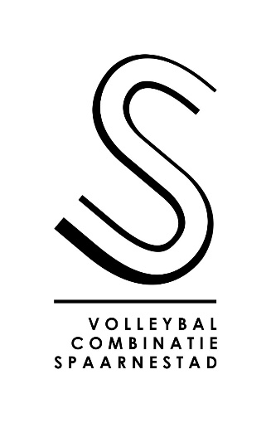
REGISTRATION FORM

Sitting volleyball tournament
VC Spaarnestad
3rd edition

Saturday 11 and Sunday 12 June 2022

Venue:
Yvonne van Genniphal
Sportweg 7
2024 CN Haarlem
The Netherlands

NAME OF THE TEAM:

CONTACT:

EMAIL ADDRESS:

MOBILE PHONE NUMBER (INCLUDING COUNTRY CODE):

STREET ADDRESS:

COUNTRY:

My team wishes to register to take part in the VC Spaarnestad sitting volleyball tournament 2022, in the following category: (Please tick (X) the appropriate category.)

[ ] 1a) Premier Division/international – 2 days (Sat. 11 June and Sun. 12 June)

[ ] 1b) Premier Division/international – 1 day (Sat. 11 June only)

[ ] 2) 1st Division – 1 day (Sat. 11 June only)

Please return the completed registration form by email to robindehaan78@gmail.com.
The deadline for registration is 15 May 2022. After we have received your registration, we will send you a confirmation email with instructions for the payment of the registration fee.

